**Bot Notifications Troubleshooting Guide**

1. **Guidelines for BOT Setup during the Application Deployment**
2. Run the automation script in full deployment mode (including addins and Bot).
3. The script will ask for the Bot Name -> Give Application name as Bot name with the suffix -Bot.
4. After the completion of the script go to <https://dev.botframework.com/bots/new> and register the bot with the same name which is given in the script.
5. Enter the **Message End Point** URL as **https://<applicationURL>/api/messages**
   1. Eg: https://contoso.com/api/messages
6. Copy the **AppId of your application**  by logging with admin credential using url <http://apps.dev.microsoft.com> .
7. Click on Save Changes.
8. Click on “Channels” tab -> Select the “Microsoft Teams” from Add a featured channel.
9. Click on save.
10. If the Bot details are not there in the setup page then give all the details and click on configure.
11. **Issues**
12. After deployment using automation script, bot notification message is not working.

**Observations**:

* Manifest.json file need to verify weather it has the proper “BotID”
* Setup page, please verify the correct bot app details present in the appsetting.json.

**Steps to Resolve**:

1. Go to <https://dev.botframework.com/bots/new> and register the bot with the same name which is given in the script.
2. Enter the **Message End Point** URL as **https://<applicationURL>/api/messages**

Eg: https://contoso.com/api/messages

1. Copy the **AppId of your application**  by logging with admin credential using url <http://apps.dev.microsoft.com> .

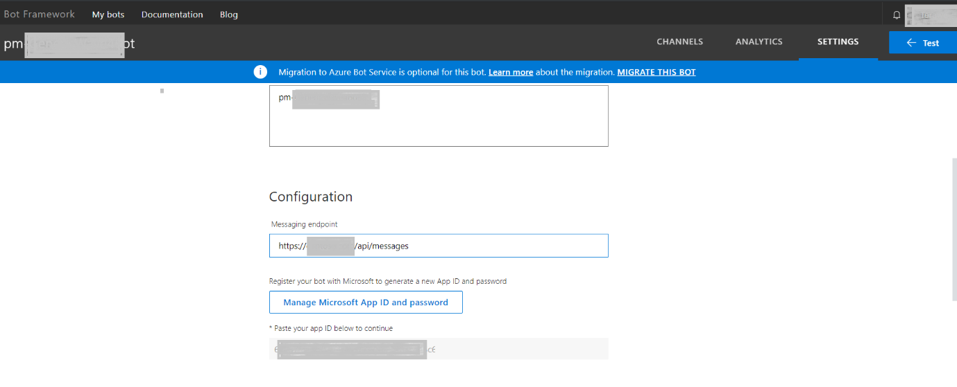

1. Click on Save Changes.
2. Click on “Channels” tab -> Select the “Microsoft Teams” from Add a featured channel.

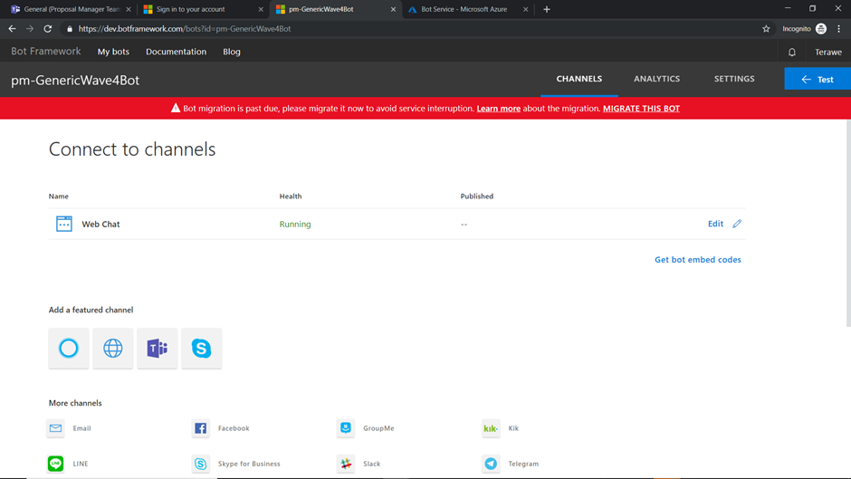

1. Click on save.

